🔷 Lab 1: Overview of Cloud Computing (Hands-on Intro)
🎯 Objective
Understand cloud vs traditional setup by actually provisioning resources.
🧪 Demo Steps
- Go to Microsoft Azure Portal
- Click Create Resource → Virtual Machine
- Configure:
  - Resource Group: RG-CloudDemo
  - VM Name: demo-vm
  - Region: Central India
  - Image: Windows Server / Ubuntu
- Click Review + Create → Create
💡 Explain While Doing
- No hardware setup needed
- Provisioning takes minutes vs weeks (on-prem)
- Everything is managed via UI/API
🔍 Key Concept
👉 Cloud = On-demand availability of computing resources over internet

Connect vis ssh
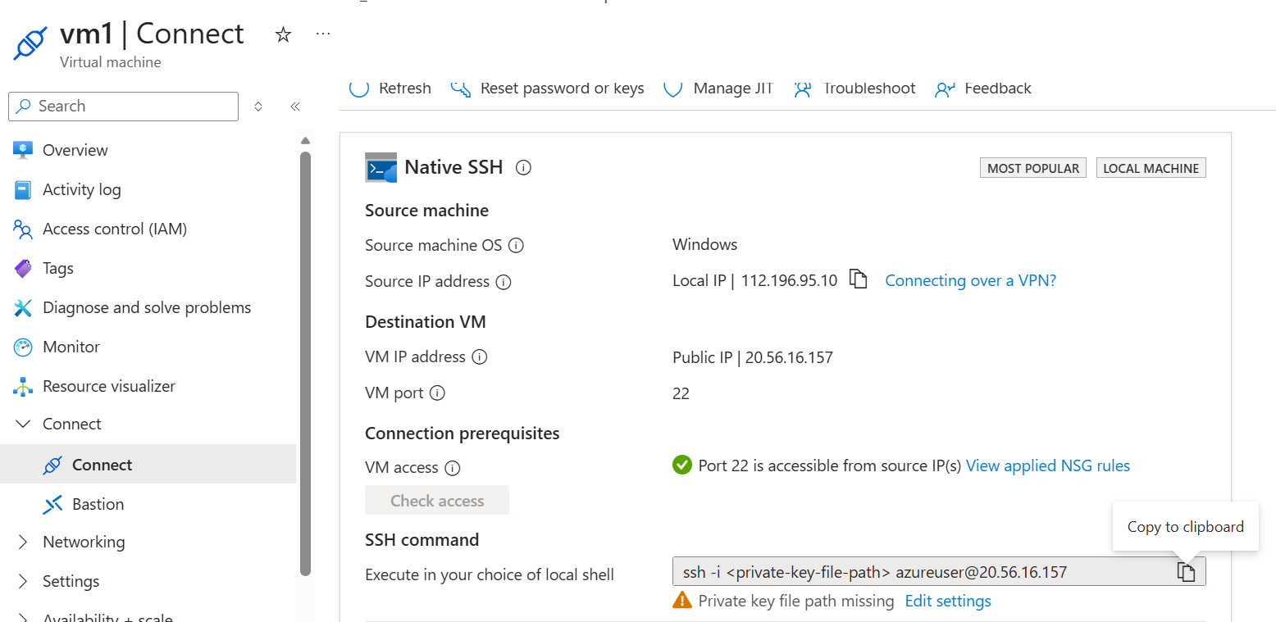

Error - Permissions for '.\\vm1_key.pem' are too open. It is required that your private key files are NOT accessible by others.

Simpler GUI Method
- Right-click vm1_key.pem
- Properties → Security
- Click Advanced
- Disable inheritance
- Remove all users except:
👉 Your user account
- Give:
✅ Read permission only

🔷 Lab 2: Benefits of Cloud Computing
🎯 Objective
Show real benefits using Azure features
🧪 Demo Activities
1. Scalability Demo
- Go to VM → Size
- Change from small → larger size
👉 Explain:
- Vertical scaling (resize VM)
- Horizontal scaling (VM Scale Sets concept)

2. High Availability Demo
- Show Availability Zones
- Explain fault tolerance

3. Pay-as-you-go
- Go to Cost Management + Billing
- Show pricing model

💡 Benefits Mapping
Feature | Demo
Scalability | Resize VM
Availability | Zones
Cost Efficiency | Billing
Global Reach | Regions

🔷 Lab 3: CapEx vs OpEx (Practical Understanding)
🎯 Objective
Make learners relate finance concept with real Azure billing
🧪 Demo
Step 1: Traditional (Explain)
- Buying servers = CapEx
Step 2: Azure (Show)
- Go to:
👉 Cost Management → Cost Analysis
💡 Explain
Type | Meaning | Example
CapEx | Upfront investment | Buying servers
OpEx | Pay per use | Azure VM hourly billing
👉 Example:
- Stop VM → Billing stops (OpEx advantage)

🔷 Lab 4: Public Cloud (Hands-on)
🎯 Objective
Show shared infrastructure model
🧪 Demo
- Create:
  - Storage Account
- Access via:
  - Public endpoint
💡 Explain
- Managed by Microsoft
- Multi-tenant environment
- Accessible via internet

🔷 Lab 5: Private Cloud (Concept + Simulation)
🎯 Objective
Understand controlled environment
🧪 Demo (Conceptual)
Since private cloud isn't fully available in free labs:
Show:
- Azure Stack concept (explain)
- Restricted access via:
  - Networking (NSG rules)
Activity:
- Go to VM → Networking
- Add rule:
  - Allow only your IP
👉 Simulates private access

🔷 Lab 6: Hybrid Cloud (Best Demo)
🎯 Objective
Connect on-prem + Azure
🧪 Demo Option 1 (Simple)
- Explain real-world scenario:
  - Bank keeps DB on-prem
  - App hosted on Azure

🧪 Demo Option 2 (Hands-on Lite)
- Create:
  - Virtual Network
- Show:
  - VPN Gateway option
👉 Explain:
- Site-to-Site VPN
- Hybrid connectivity

🎯 Real-World Mapping (Very Important for Learners)
🏦 SmartBank Example
Component | Deployment
UI | Public Cloud (Azure App Service)
Database | Private Cloud / On-Prem
Integration | Hybrid Cloud

🧠 Trainer Tips (High Impact)
- Ask learners:
👉 “What happens if VM is stopped?”
- Show live billing impact
- Let them:
✔ Create their own VM
✔ Stop it (cost control learning)

📌 Quick Recap for Learners
- Cloud = On-demand services
- Public Cloud = Shared (Azure)
- Private Cloud = Dedicated
- Hybrid = Combination
- CapEx → Buy
- OpEx → Rent

